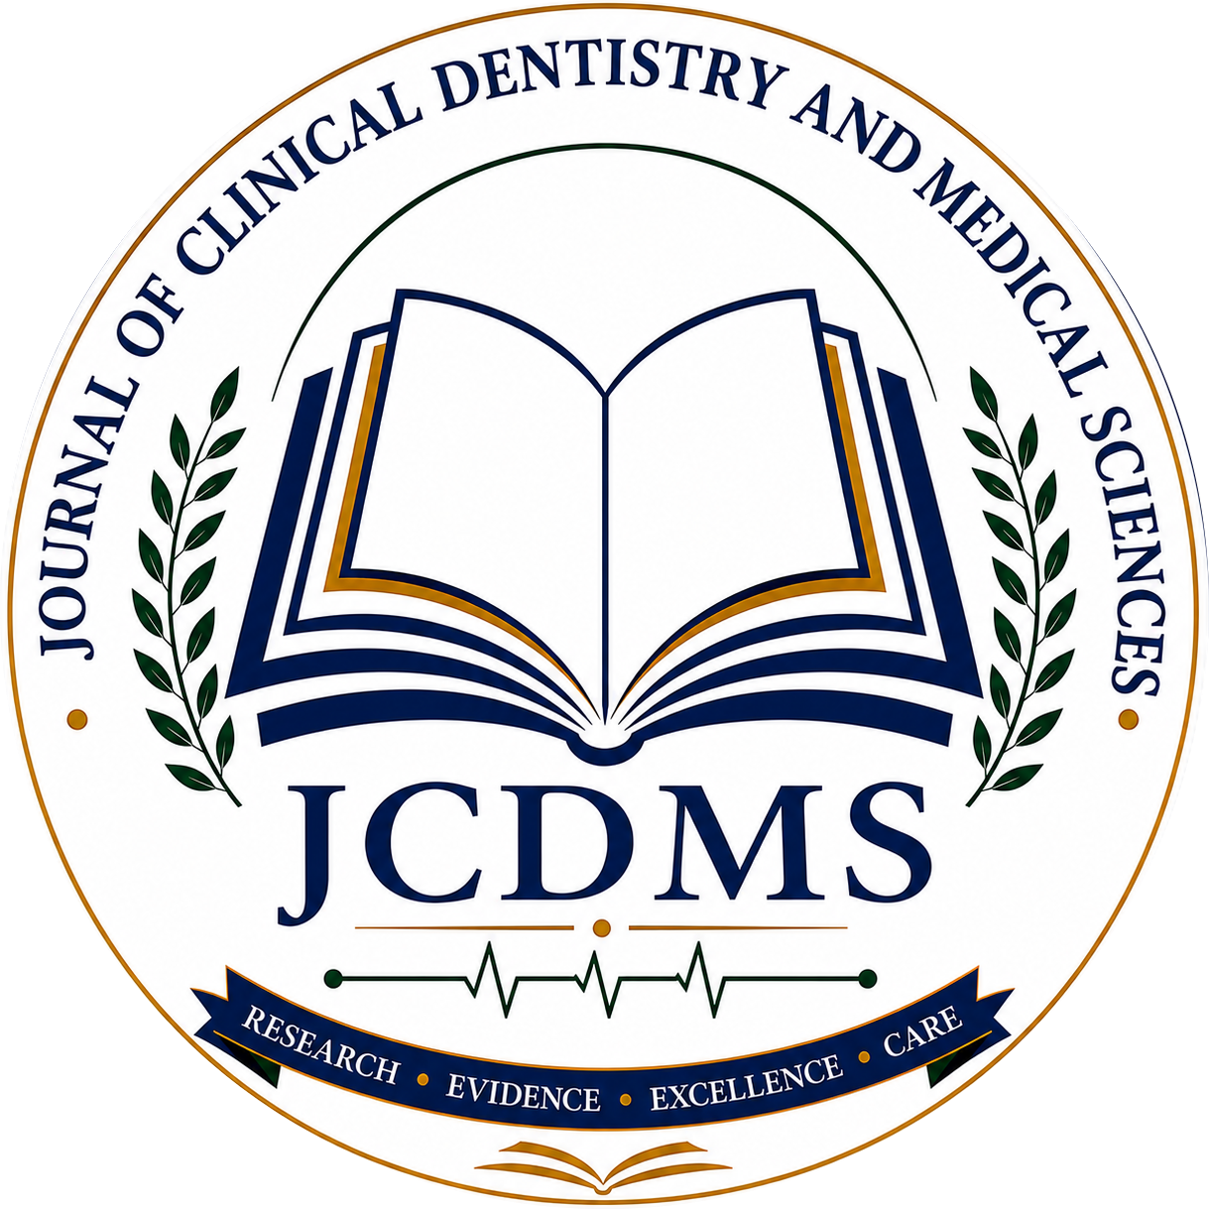 | JCDMS  Journal of Clinical Dentistry and Medical Sciences  Published by Dr STATS Publishers

COPYRIGHT & AUTHOR DECLARATION FORM
To be completed by the corresponding author on behalf of all co-authors. Complete all applicable fields and sign before submitting to the journal.

1. Manuscript information
Manuscript title: ___________________________________________________________________
Article type: ___________________________________________________________________
Manuscript ID (if assigned): _____________________________________________________
Corresponding author (full name): _____________________________________________________
Email address: ___________________________________________________________________
Institution / affiliation: _____________________________________________________

2. Author declaration
☐ Originality and exclusivity: The manuscript is original, has not been published previously, and is not under consideration by another journal, except where fully disclosed to JCDMS.
☐ Authorship and approval: All listed authors meet the applicable authorship criteria, have reviewed and approved the submitted version, and authorize the corresponding author to communicate with JCDMS.
☐ Ethics and permissions: Applicable ethics approvals, informed consent (including consent for identifiable material), and permissions for third-party content have been obtained, where required.
☐ Transparency: Funding sources, competing interests, and any relevant disclosures have been accurately reported in the manuscript.
☐ Accuracy: The information supplied in this form is accurate to the best of the signatory’s knowledge.

3. Copyright and open-access licence
Authors retain copyright in their work. If the manuscript is accepted and published, the authors grant JCDMS (published by Dr STATS Publishers) a non-exclusive right of first publication and permission to publish and disseminate the article as the original publication.
The published article will be made available under the Creative Commons Attribution 4.0 International licence (CC BY 4.0), which permits sharing and adaptation, including commercial use, subject to appropriate attribution, a link to the licence, and indication of changes.
☐ On behalf of all authors, I confirm agreement with the above copyright and licensing terms if the manuscript is accepted for publication.

4. Signature and authorization
I confirm that I am authorized to submit this declaration on behalf of all listed authors.
Corresponding author signature: ________________________________________________________
Printed name: ________________________________________________________
Date (DD/MM/YYYY): ________________________________________________________
Place: ________________________________________________________
Important: Submission of this form does not imply acceptance. Editorial assessment and peer review remain applicable.

